FAKE MEDIA DETECTION IN ARMED CONFLICTS IN INDIA
- The project focuses on detecting fake media (both text and images) related to armed conflicts using machine learning and deep learning techniques.
- A user-friendly graphical user interface (GUI) is developed using Tkinter to allow easy interaction with the system.
- The system supports two types of inputs: text data (news/articles) and image data.
- For text analysis, TF-IDF vectorization is used to convert text into numerical form, and a Support Vector Machine (SVM) model is used for classification.
- For image analysis, a Convolutional Neural Network (CNN) model is used to classify images as real or fake.
- The system includes dataset upload functionality for both text and images.
- Data preprocessing is performed to clean and prepare the dataset for model training.
- The system splits the dataset into training and testing data for proper evaluation.
- Model training is performed separately for text and image data.
- Performance metrics such as Accuracy, Precision, Recall, and F1-Score are calculated to evaluate the models.
- Confusion matrices are generated to visually analyze prediction performance.
- The system provides real-time testing where users can input new text or upload images for prediction.
- The output is displayed clearly in the GUI, indicating whether the content is real or fake.
- The system helps in reducing misinformation and supports decision-making in critical scenarios like armed conflicts.
- Overall, the system combines multiple technologies to provide an efficient and reliable fake media detection solution.

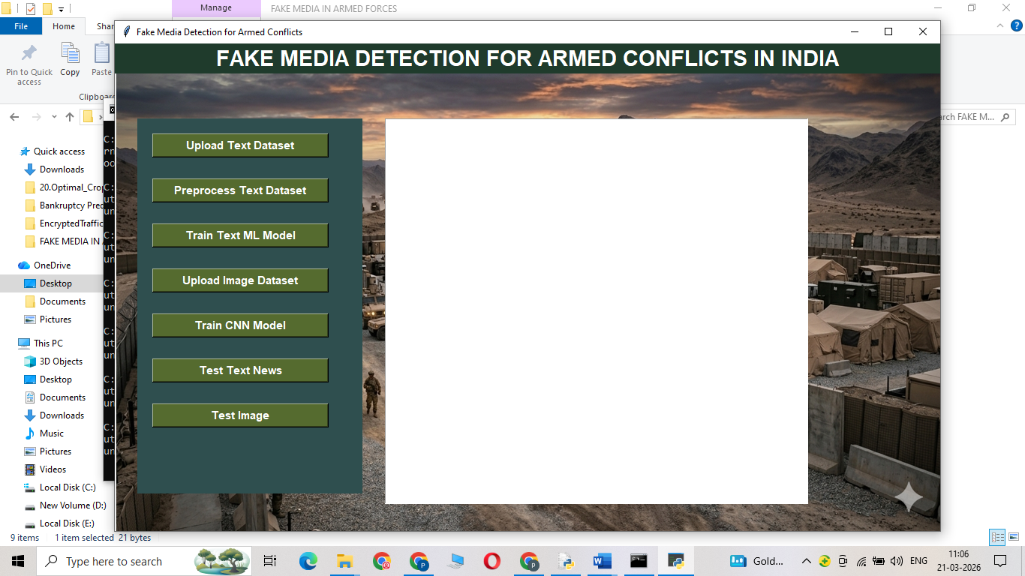

Figure 1: System Main Interface (GUI Screen)
This figure shows the main graphical user interface of the Fake Media Detection system. It contains options for uploading datasets, training models, and testing both text and image inputs. The interface is designed using Tkinter to provide easy interaction for users.

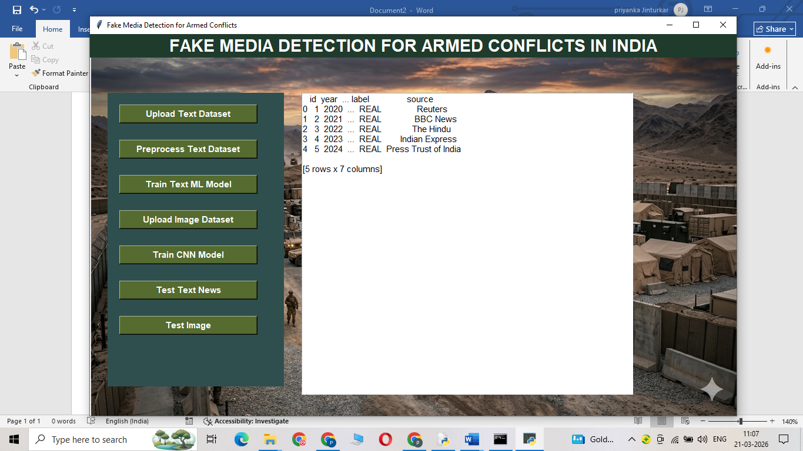
Figure 2: Upload Text Dataset Screen
This figure represents the process of uploading a text dataset into the system. The dataset is loaded in CSV format and displayed in the text area for verification. This step allows the system to read and prepare data for further processing.

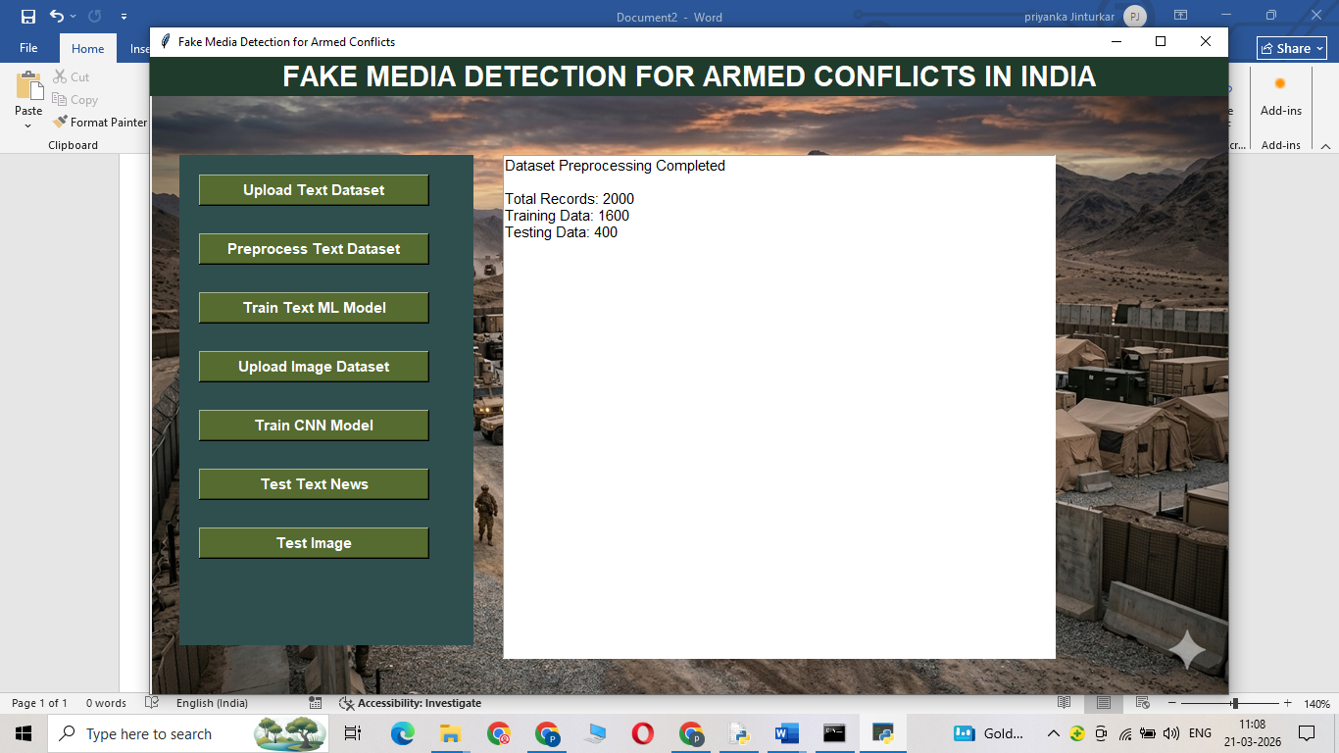
Figure 3: Text Dataset Preprocessing Output

This figure shows the output after preprocessing the text dataset. It includes details such as total records, training data size, and testing data size. Preprocessing ensures data cleaning and proper formatting before model training.

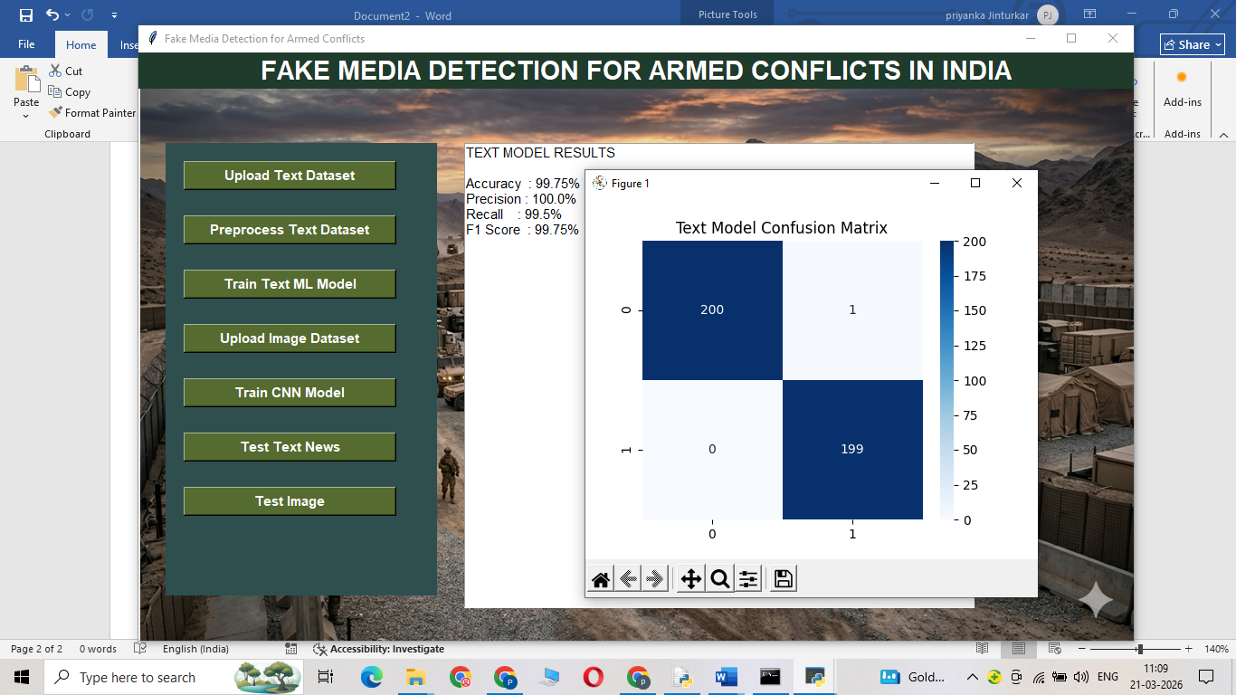
Figure 4: Text Model Training Results
This figure displays the performance metrics of the trained text classification model. Metrics such as accuracy, precision, recall, and F1-score are shown. These values indicate how well the model can classify news as real or fake.
This figure presents the confusion matrix for the text model. It visually represents correct and incorrect predictions made by the classifier. This helps in analyzing model performance and identifying misclassification patterns.

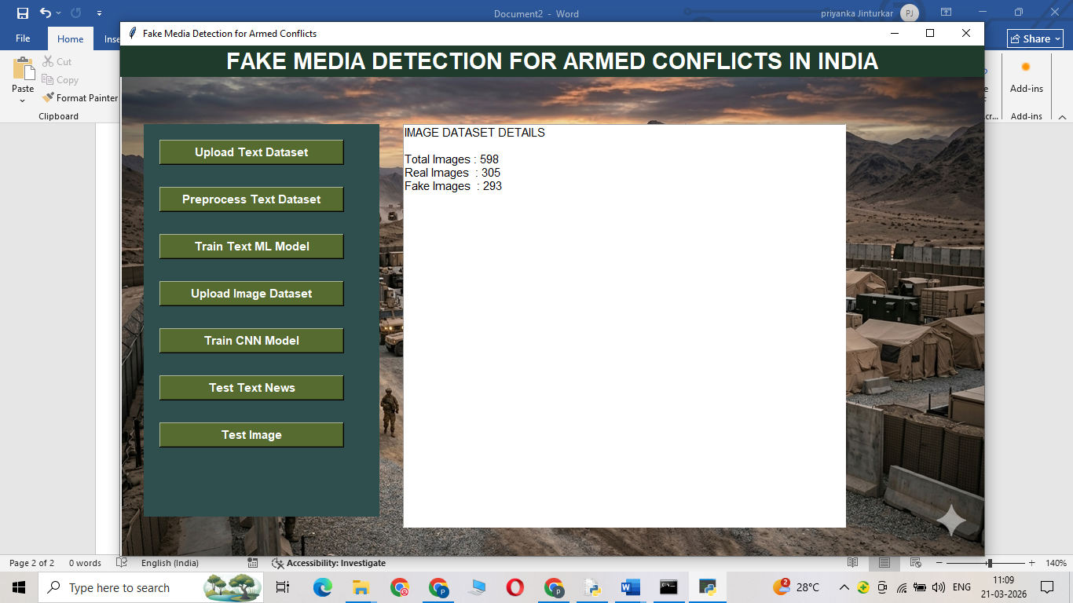
Figure 5: Image Dataset Details Screen
This figure shows the information about the uploaded image dataset. It displays the number of real and fake images present in the dataset. This helps in understanding dataset distribution before training the CNN model.

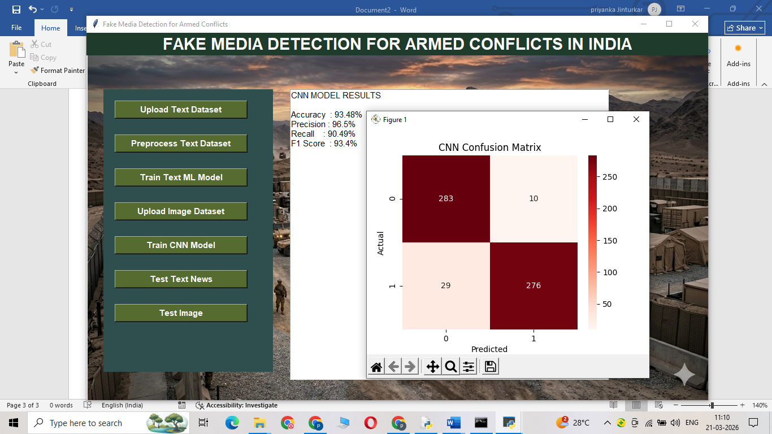

Figure 6: CNN Model Performance Results
This figure displays the evaluation results of the CNN model used for image classification. It includes accuracy, precision, recall, and F1-score. These metrics show how effectively the model detects fake images
This figure shows the confusion matrix for the image classification model. It provides a graphical representation of actual vs predicted values. This helps in evaluating how accurately the CNN model performs.

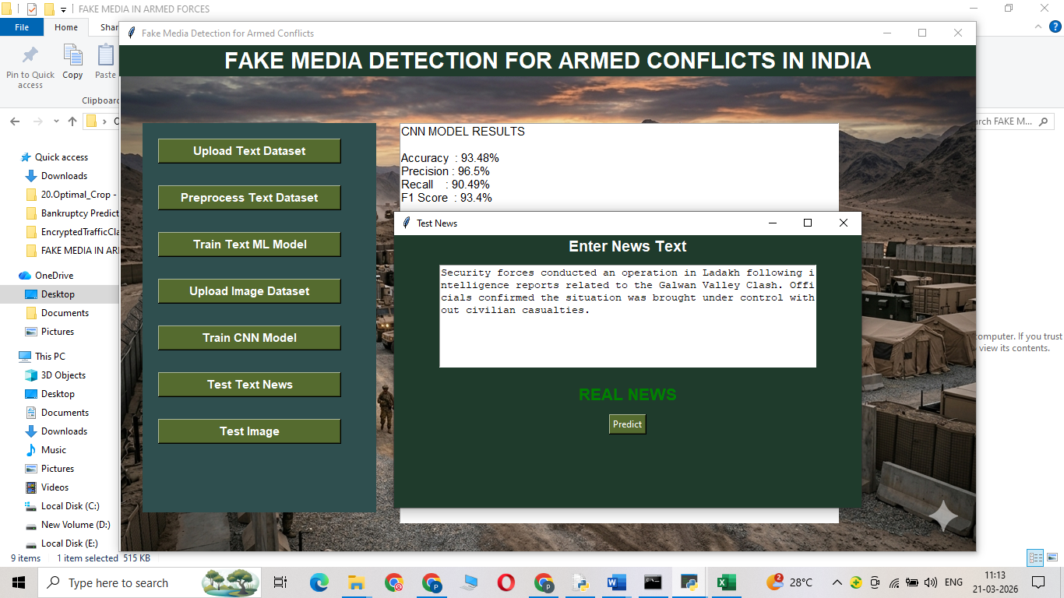
Figure 7: Text Testing Output (Real Prediction)
This figure represents the testing of new text input provided by the user. The system predicts whether the news is real or fake and displays the result. This demonstrates the working of the trained text model. The given text is predicted as Real.

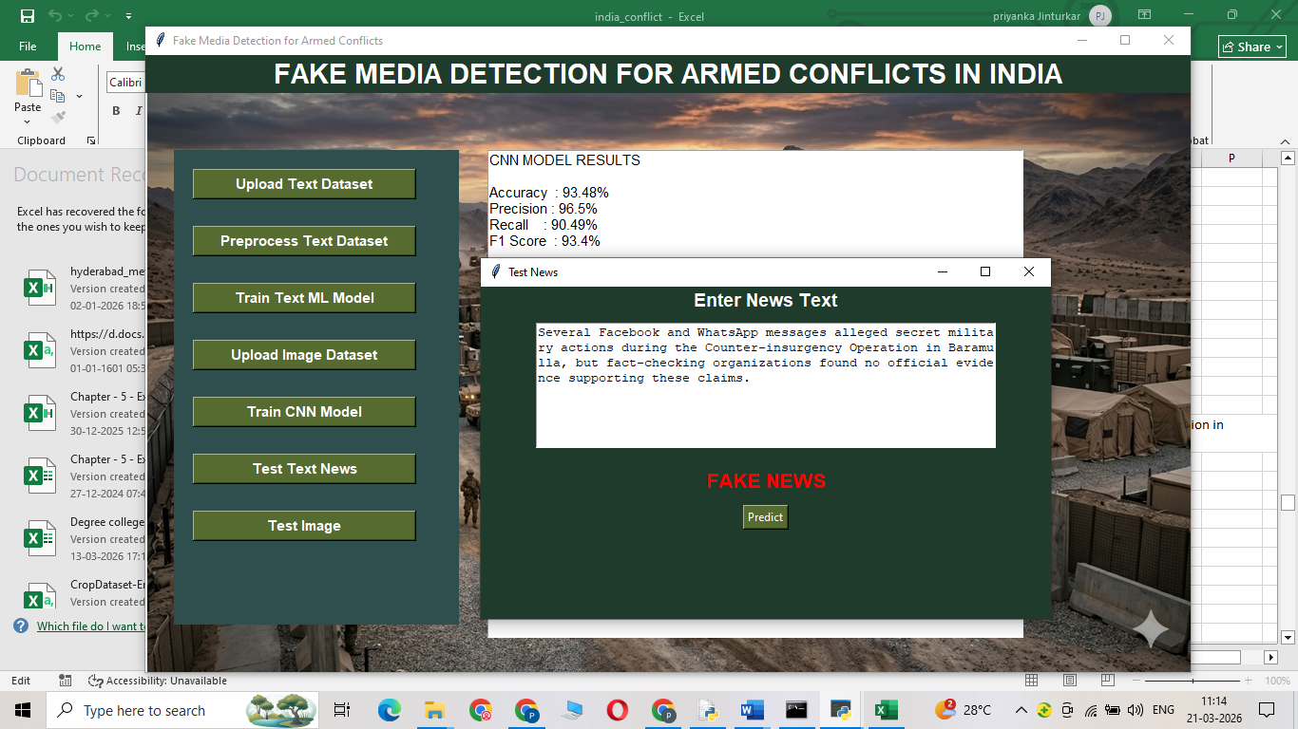
Figure 8: Text Testing Output (Fake Prediction)
This figure represents the testing of new text input provided by the user. The system predicts whether the news is real or fake and displays the result. The given text is predicted as Fake.

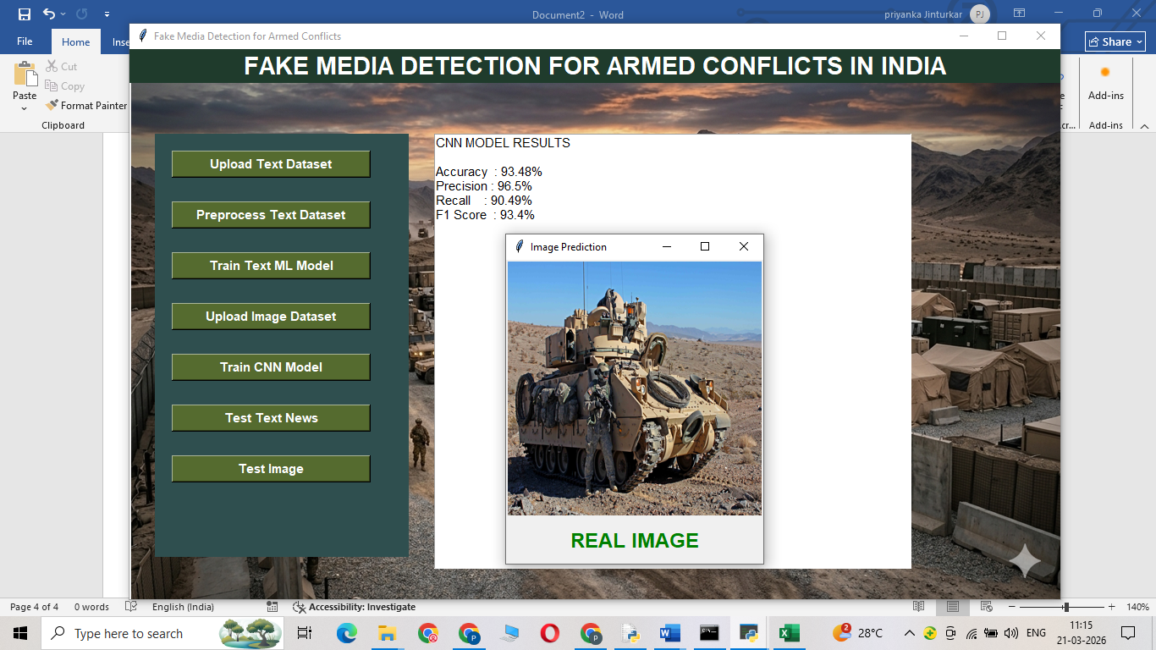
Figure 9: Image Testing Output (Real Prediction)
This figure shows the testing of an uploaded image. The system processes the image using the CNN model and displays whether it is real or fake. This confirms the effectiveness of image-based detection.
The above uploaded image predicted as Real.

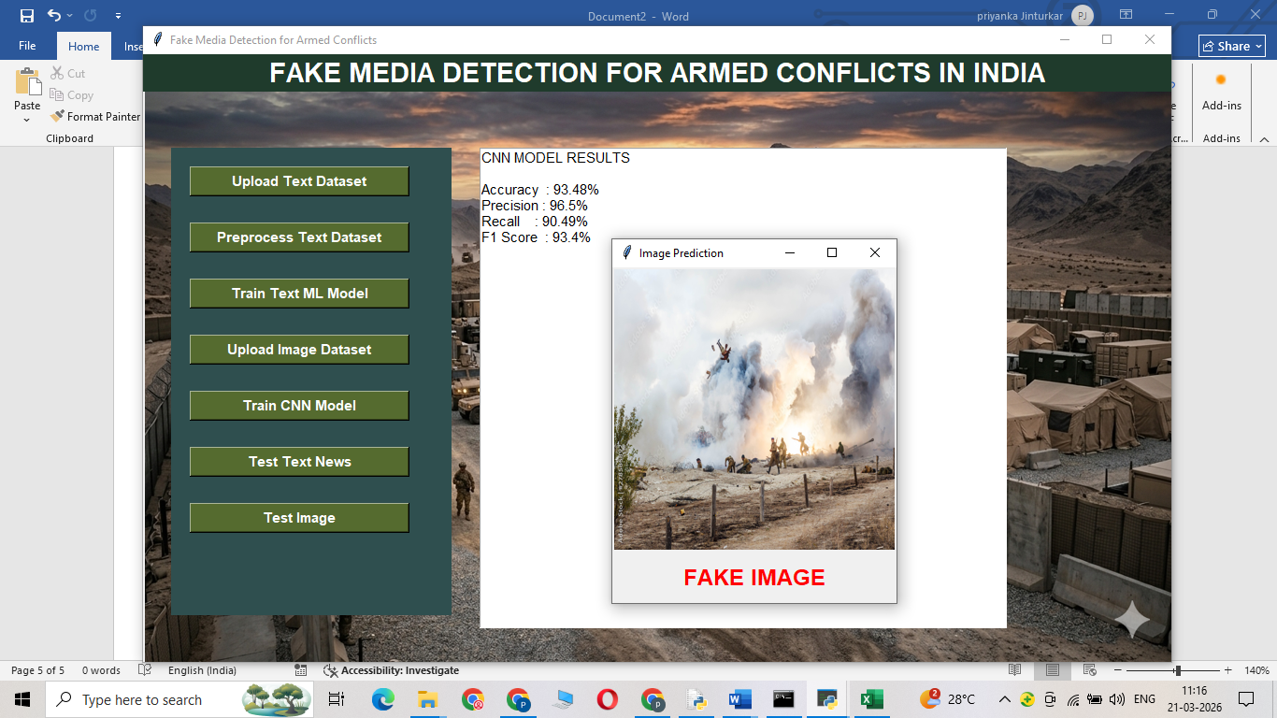
Figure 10: Image Testing Output (Fake Prediction)
This figure shows the testing of an uploaded image. The system processes the image using the CNN model and displays whether it is real or fake. The above uploaded image predicted as Fake.

